Q. 1)
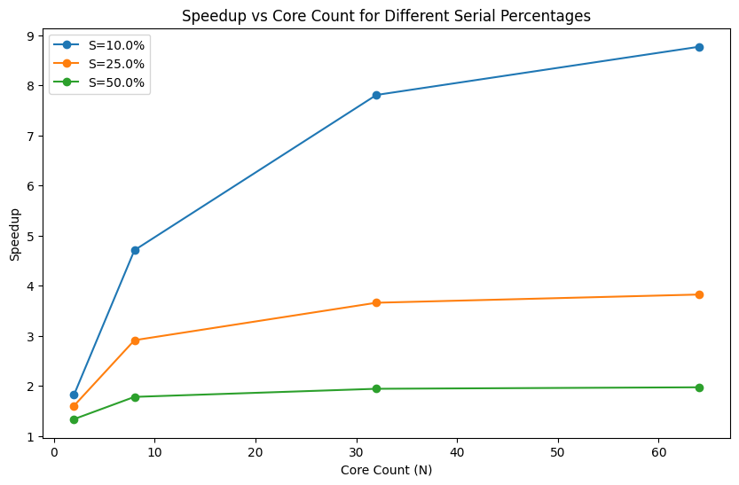
Q. 2)
Multithreading may not provide better performance than a single-threaded solution in scenarios where the tasks to be performed are not independent or cannot be parallelized. An example would be a file copying program.
Q. 3)
Yes, the performance of the multithreaded program will vary between computers A and B due to the difference in the number of cores.
Q. 4)
Synchronous – The main thread would create a new thread for each sum, and then wait for each thread to complete before moving on.

Q. 5)
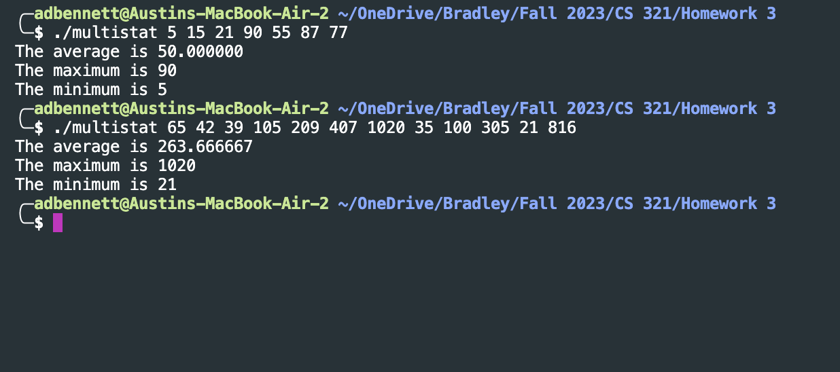
Q.6)


